MINSTERLEY PARISH COUNCIL

Parish Plan
Minsterley Parish Plan
Plus: Update Sept 2022 Linking Station Road Footways see Appendix A ↓
Minsterley Village Appraisal from ‘A Snapshot in time 1997’
This document is an update of the final report first amended 2003.
Final Report please note that the survey results are out of date and more up to date survey is required.
1/ Introduction and description of the Appraisal process
2/ A Brief description of the Parish of Minsterley
3/ Opinions and recommendations:
(a) Public Transport
(b) Road Safety
(c) Young People
(d) Children
(e) Heritage
(f) Recreation & Sport
(g) Local Services
(h) Parish Hall
(i) Employment
(j) Housing
(k) Access to the Countryside
(l) Senior Citizens
(m) Local Councils
4/ Minsterley Parish Plan Update Sept 2022 see Appendix A on Page 23
Linking Station Road Footways ↓↓

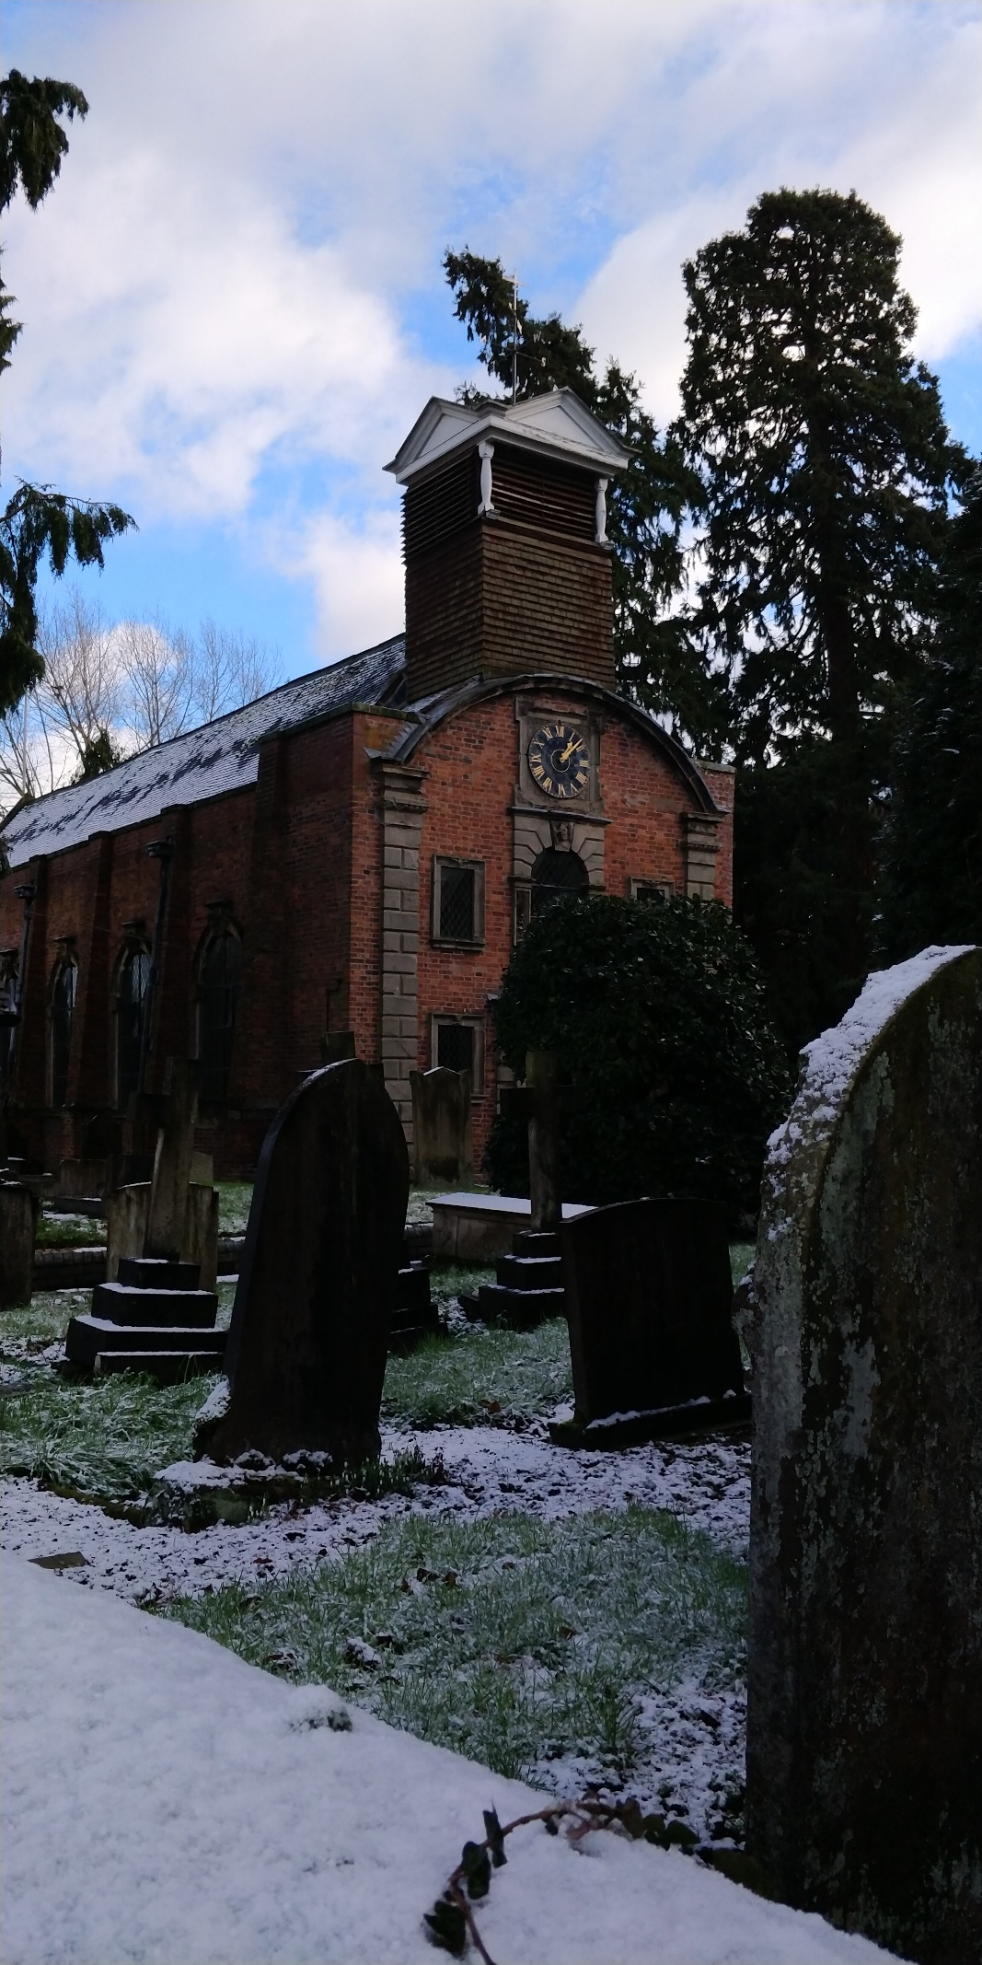
INTRODUCTION
The aim of this village appraisal has been to take a ‘snapshot in time’ of opinion within the Civil Parish of Minsterley. This will we hope:-
1/ help to identify priorities for future planning and projects;
2/ support campaigns on particular issues and for facilities the village needs;
3/ provide targets to aim at and commentary on existing ideas; and
4/ encourage people to get involved in the life and development of our local community.
The work has been carried out by a voluntary group which came together following an open meeting in the summer of 1997 arranged under the sponsorship of the Parish Council which has retained and interest in the appraisal process. The questionnaire forms went out in the autumn of 1997 and were collected in within about 4 weeks of their being sent out.
Preparation, distribution and collection of the appraisal questionnaire was the work of volunteers, and so was some of the interpretation of the completed questionnaires. The project was able to employ a graduate, Rachael ___, to do most of the number crunching and to carry out some supportive research. We are also grateful for the help provided by the Leader11 office in Bishops Castle.
Financial support and technical help was provided by outside bodies including SABC The community Council for Shropshire and the Clun Valley Leader 11 project financed from European funds. Minsterley school, the Post Office, the Parish Hall and Holy Trinity Church provided facilities when needed. In addition a photography project running alongside the appraisal process was supported by Media Arts in Rural Shropshire and rural Action.
Though we hope that this report will be of interest in it’s own right the process will only really have been worthwhile if it leads to further work to enhance our village and it’s environment and facilities. Each chapter closes with recommendations driving from comments made on completed questionnaires and at open meetings before and after the appraisal process. It will not be the task of the appraisal group to take these forward nor will it necessarily be the task of the Parish Council or other statutory bodies though they will of course be taking seriously all the comments criticisms and opinions expressed here. The challenge is to all of us to work together to build the sort of community we want and need here in Minsterley.
A BRIEF DESCRIPTION OF THE PARISH OF MINSTERLEY
The village of Minsterley has a long history, having developed from early beginnings as a small hamlet and agricultural community, through the growth in population that accompanied the mining activities in the area to its present status as the major centre of employment in the Rea Valley area. The village is situated in the wide Rea Valley close to Callow Hill and the Stiperstones and on the main A488 Shrewsbury to Knighton road. At one time the village was also a railhead. The Minsterley brook fed from the Stiperstones runs through the village centre. Minsterley Hall is a Tudor country house of some note which underwent recent restoration by a previous owner and is now looking to host a venue business. Outlying areas include Horsebridge, Etsell, Plox Green, Wagbeach, and Waterwheel.
A substantial number of the local population work for the 2 firms which are the main employers in the village. These are the Minsterley Creamery of Muller employing over 250 people on site (some working shift patterns covering 24 hours) as well as tanker drivers, and Rea Valley Foods which cooks and cans meats. There are also people travelling to and from work at both these sites. Other significant employers are David Davies & Sons egg producers and arable farmers, Hillcrest Manor Nursing Home, the Malthouse Veterinary Surgery. The village is served by a Co-Op convenience store and Petrol station. The village formerly hosted 3 public houses grouped together in the village centre but two of these have been lost to development leaving only the Crown & Sceptre. There are 2 takeaway eateries.
One employer commented that local people helped to create a family atmosphere; another preferred to employ local people because of problems travelling a distance in bad weather.
Further service outlets in the village include a Butchers a Flower shop a Hairdressing salon and Shropshire Pressure washers. There are many fewer shops than in times gone by but the Minsterley and Pontesbury area is still better served than many rural communities. Most people shopping in the village are fairly local with some from the Hope Valley, Snailbeach, Westbury, or Worthen and smaller communities in between. Stores like the Co Op stores are used mostly for convenience shopping now with people doing their ‘main shop’ at supermarkets.
A fairly good bus service to Shrewsbury is operated by Minsterley Motors Stiperstones; in the other direction some buses run through to Bishops Castle, Stiperstones/Pennerly and on a less than daily basis beyond.
There are four churches: 2 Anglican (including St Lukes Snailbeach, just within the parish boundary) one Methodist and one Congregational. Roman Catholic and Baptist congregations worship in Pontesbury and there is an independent evangelical church at Brockton by Worthen. Methodist and Anglican ministers live within the village and there is a Congregational minister at Pontesbury. The Minsterley Methodist Circuit covers most of the Rea Valley area and out onto the Long Mountain.
There is a fire station in the village with a retained crew. The area Police station is in Pontesbury where there are also Doctor’s and Dentist’s surgeries. There are also medical practices at Westbury and Worthen.
The Primary school in the village has about 120 pupils (and rising) an independent nursery also uses premises at the school and has over 60 children on roll. There is also a mother and toddler group in the village. Most older children attend the Mary Webb School in Pontesbury to the age of 16. Sixth Form and FE Colleges are situated in Shrewsbury.
As well as the privately-owned Hillcrest Manor Nursing Home there is a sheltered development of council-owned dwellings for older people at Longleat Close. This houses between 40 & 50 people in 35 single bedroomed and four double bedroomed bungalows. There is a warden who lives in and the common room is used for a number of social events which are also attended by a few people living outside the development.
General housing in the village is a mixture of private and council owned homes. There are four estates of private properties developed over recent years and one of mainly social housing. There is imminent development of a further estate of 27 houses and planning at Little Minsterley for a further development.
Two significant local events are the long established Minsterley Show(2019 was its 144th year though now at Lea Cross and no longer in Minsterley Parish there is no intention to change its name); and the Minsterley Eisteddfod which attracts entries from far and wide as well as from the immediate area. There is a large Parish Hall used for the Eisteddfod and other big events but also by local groups of various kinds. There is a sports field and Football and rounders clubs. The Minsterley Branch of the Royal British Legion is no longer active but the Parish Council has taken on remembrance duties. There is a good neighbours scheme in the village with a voluntary car scheme. Older residents benefit from a meals on wheels service. There is a mobile library service to the village once a week.
OPINIONS & RECOMMENDATIONS
A/ PUBLIC TRANSPORT
Minsterley is served by the Bishops Castle to Shrewsbury service operated by Minsterley Motors. Not all buses run through to and from Bishops Castle some run from Stiperstones and Snailbeach and others terminate at Plox Green. There is a fairly regular service throughout the day but except of Fridays and Saturdays there is no bus out of Shrewsbury after 6:05 p.m. Minsterley also operate a weekly bus to Newtown and Arriva a weekly bus to Ludlow. One college service each way is operated by Longmynd Travel and there is also a weekly bus from Bishops Castle to Shrewsbury operated by Horrocks and serving some of the smaller villages. At the time of the survey Sunday services had been recently withdrawn. An evening service between Minsterley and Shrewsbury on Fridays and Saturdays operated by Arriva as an extension of its Radbrook Green service was under threat. Both these services and certain others were Shropshire Bus services subsidised by the County Council.
There was generally a feeling that Minsterley was fairly well served by public transport compared with other village communities though some respondents described the service between Minsterley and Bishops Castle as ‘patchy’ There had been an improvement in the standard of buses over recent years but these were still older vehicles and there were access problems for the elderly and disabled. However staff were friendly and helpful and a number of people declared themselves ‘satisfied with the service as it is’ About one in 5 of those who responded used public transport weekly or more often(though only 4% used it daily) Some 70% used public transport ‘rarely or never’.
People were separately questioned about the Park & Ride service into Shrewsbury town centre. Buses run from Meole Brace and Oxon both readily accessible from Minsterley. Buses are Modern, with easy access. Over 50% of respondents used this service rarely or never but nearly 20% used it a t least once a month.
Most use of public transport was for shopping and social purposes. Of those using public transport 10% use it to travel to work, and 8% to travel to school or college though this figure may be lower than the real situation as fewer forms were returned from this age group. People do also travel into Minsterley regularly by bus of course including those who travel to work in the village.
The questionnaire asked what would encourage better use of public transport. Not surprisingly many people asked for cheaper and more frequent services, One particular point made but a number of people was that there is no return fare – a return fare discount and season ticket facilities would encourage more use. A slightly later bus back from Shrewsbury on weekdays might be more convenient for those who work out of the town centre and some travelling in by train or bus from elsewhere. A few of those responding asked for a service timed at around 6:30-45 pm from the town centre.
Over 70% of those responding thought that the Parish Council should join with others locally to provide a subsidy for a Sunday bus service. This was little used however prior to its withdrawal and most of those making comment felt that it was unlikely ever to be viable. There was a much stronger feeling in favour of late evening buses; the Friday and Saturday services have been well used and there was some demand for late buses on other days.
Other points raised were: the cost of student travel(this is subsidised but the pass is still costly yet permits travel at very specific times penalising students choosing to return home at free periods in the day or to work late at college); difficulty in obtaining accurate timetable information though provision of timetables at village bus stops was appreciated; a request that bus times might be synchronised with surgery times at Pontesbury; provision of a weekly workers pass; and the need for more stopping points in Shrewsbury Town centre.
Recommendations
a) The late evening buses on Fri/Sat to be retained even if subsidy for this service is withdrawn
b) Details of the park and ride services should be publicised in the parish to encourage usage
c) Particular issues such as return fares weekly tickets and a later bus from Shrewsbury were raised with the bus operator but not financially viable.
d) Regular contact between the Parish Council and the main bus operator should be established so that the public transport issues are discussed as they arise. A public forum or a public transport report at the Annual Parish meeting may also be useful.
(These issues were all raised)
Some of the operators may have changed but the services are still good and possibly improved. Improved buses mean better access. Shropshire hill service in summer. Idea of discussion still valid (why not use bus stop in village?)
B/ ROAD SAFETY
Roads in Minsterley are quite busy and the village has an important junction between the A488 Shrewsbury to Bishops Castle Clun and Knighton road and B roads leading to Brockton and Worthen(and on to Montgomery and Welshpool) and Westbury. The A488 is of fairly high quality as it passes through the village and is well lit in the village itself. The B roads are also of reasonable quality in Minsterley itself though not so good beyond the immediate village boundary. Two particular areas of concern addressed in the Appraisal questionnaire were the stretch of road by the shops and parish church where there is substantial pedestrian use and many cars are parked and the stretch of the A488 past the primary school. A substantial amount of traffic including heavy goods vehicles is generated locally so a by-pass is probably not a solution to traffic problems in Minsterley. The Parish Council is actively in pursuit of VAS to calm traffic.
The questionnaire asked specifically what importance people attached to the provision of a footpath and cycle path along the Leigh rd to the cemetery. Completed questionnaires also revealed large majorities in favour of 4 particular road safety measures viz.; better crossing facilities by the bridge in the village square; traffic calming measures; road safety training for children; and cycle proficiency training and testing. The least popular of these, traffic calming ‘ still attracted a vote in favour of over 80%.
There were many suggestions and comments on the subject of road safety outside Minsterley school. A number of people commented that parents were using cars unnecessarily though others acknowledged that parents were often travelling on elsewhere by car e.g. to work, after dropping children off at school. It was strongly suggested that the lay-by outside the school be extended and perhaps re-organised to allow parking in an offset pattern, some respondents felt that this should be coupled with a ban on parking on the school side of the road. Other suggestions included the used of different coloured tarmac; extending the barrier outside the school gates; installing speed cameras and enforcing a stricter speed limit past the school at times when children were arriving or leaving. It was generally felt that traffic was travelling too fast ion this section of road, and a number of people asked for a 40mph speed restriction from Plox Green through to where the 30mph restriction begins. It was felt that some setting a bad example to children by not crossing the road carefully themselves and a very high proportion of questionnaires called for a school crossing patrol.
Concern for the safety of children was also evident in the request that pavements be widened. There were a number of places where children and the elderly needed to cross busy roads and this was a cause for concern. Traffic calming measures in the area of the square could help here. The parking of cars by the telephone box at the bottom of of Callow Lane was also perceived as causing a hazard. There were requests for a second foot crossing to be provided on the other side of the bridge in the village centre.
Another concern expressed was that young riders were regularly using cycles without lights and, on occasions motor cyclists with no helmets in and around the village.
There were many suggestions for traffic calming measures. Some of those responding made favourable comment about the A49 through Craven Arms and asked whether something similar could be tried in Minsterley. Others felt that side roads could be made safer if traffic calming measures similar to those in on the Crowmoor estate in Shrewsbury or outside the Trinity School at Ford were introduced. Rumble strips were not popular causing annoyance to nearby residents whilst making little contribution to road safety.
There were several requests that a pavement be provided on the east side of the A488 between the Square and the Parish Hall. Concerns were expressed that lorries are still using Callow Lane and that heavy plant was moved on occasions in the early hours or late at night. There were comments about the excessive parking on pavements in the area towards the Malthouse surgery which made passage difficult for parents with young children. Pedestrian visibility was poor at the island between the Leigh and Horsebridge roads and signs should be provided to warn on coming drivers.
There were few solution on offer to the congestion outside the village shops though this was widely acknowledged as a problem. The narrow bridge did at least serve to to slow traffic and any improvements that actually increased the speed at which vehicles travelled through this area would be detrimental. Car parking is further discussed elsewhere in this report.
Other areas of concern included pedestrians walking with backs to oncoming traffic on roads without a pavement, an increase in heavy traffic including coaches along narrow sections of the Leigh road; very large goods vehicles using the Westbury Rd; and the need for stricter enforcement of the speed restrictions in the village.
Recommendations;
a) Further urgent study should be made of road safety on the A488 past Minsterley school including car parking there and the provision if possible of a crossing warden
b) Consideration should be given to establishing a 40 mph speed limit between Plox Green and the present 30 mph area.
c) The case should be made for provision of a footpath along Leigh Rd between Park Meadow and the Cemetery.
d) No footway signs similar to those in Horsebridge should be provided for the area between the Methodist Chapel and the island at the junction of Leigh and Horsebridge Roads.
e) Traffic calming measures should be further considered and especially any action that might make it safer for pedestrians to cross the A488 outside the Crown & Sceptre and the B4499 by the bridge.
f) Regular checks made on traffic speeds and parking in the village and;
g) If improvements are made to the bridge at any point they must be accompanied by measures to slow the speed of traffic past the village shops.
Improvements in place (parking in parish hall/ crossing speed limits/ walking bus/ path to cemetery) still improvements to be made
Pontesbury footpath was completed and has provided a boon to both Parishes but has created an issue in that free school transport is now to be withdrawn.
PACT to check speeds
HGV’s a concern difficulty crossing in village centre identified to Highways for a new roundabout.
C/ YOUNG PEOPLE
There is a large and growing population of young people in Minsterley, which because of its local centres of employment has a lower age profile than many villages of similar size. About 15% of those who responded to the Appraisal questionnaire were aged between 11 & 21.
There is a limited youth club in the village – this facility like other areas of youth work funded by the County Council has been under threat because of budget cuts.
There was a general feeling that local facilities for young people were poor or very poor, with no-one at all marking them as very good. Just under 10% of young people completing the questionnaire were fairly regular users of the Hamlet Hopper but over ¾ never used it. A number of respondents wanted an open youth club to serve the Minsterley area(non Church as one or two pointedly commented) This could be the sort of drop in facility that was more successful than more organised ventures at ‘getting young people in off the streets’ Such a club could include a non-alcohol bar. One or two respondents commented that alcohol was a problem among young people, for whom ‘there's nothing much else to do’
Discos for young people were requested by a number of people and there were suggestions also that ‘more inventive play facilities’ be provided areas for BMX riding skateboarding or rollerblading for example. A number of respondents asked for better sports facilities which is a subject dealt with in details elsewhere in the report. Clearly none of this could happen without substantial commitment in such areas as fund raising, practical building work, and adult leadership; but there was an indication that there were people who were ready to offer help in this area.
Recommendation:
a) Any reduction in those facilities now provided should be firmly opposed.
b) A public meeting should be held to discuss ways of improving facilities fore young people including rollerblading or other similar facility locally. Young people themselves need to be involved in this and their opinions heard. A group did display a desire for a skate park but this was beyond resources of the Parish.
Demise of many of the clubs mentioned above may have been offset by the after school clubs at the primary school(a national policy)
No provision for teenaged children still a problem as in all areas
D/ CHILDREN
The appraisal questionnaire defined children as those aged under 11. Not surprisingly most people responding to it felt that provision of a safe play area was very important, and there were a number of suggestions as to how existing facilities regarded generally as on the poor for a village of this size could be improved.
There are 2 play areas in the village; in the grounds of the Parish Hall with swings and a new slide and at the end of Pine Crescent backing onto Callow Lane at present just an open space. Uniformed organisations exist locally and local churches seek to make provision for children in various ways. Trinity has a group for ages 7 to 10 which is usually fully subscribed with a waiting list. The Primary school operates football and other clubs.
Many people wanted more play facilities on the existing sites, and there was also concern that the play area by the Parish Hall was prone to vandalism. Misuse of this area by teenagers late at night was a source of great annoyance to nearby residents many of whom were elderly. Several of those responding had comments to make; for example, that this playa area might be extended that more benches could be provided, that dog mess and litter should be regularly cleared, and the place properly secured at night so that it did not become a focus for noise and vandalism. Adventure play equipment was particularly requested ‘using wood like at Pontesbury’ and there were also requests for facilities for the under 5’s. About a third of those responding were prepared to offer practical or fund raising help.
Development of the Callow Lane play area was also suggested though some people felt that it was not secure enough to be suitable for very young children. One(young) resident suggested a cycle track or assault course at the site. This site was developed into a toddlers play area.
Holiday clubs; after school ; and child care facilities were all popular suggestions. Many households with children had both parents at work. The children’s discos run from time to time were popular and more would be appreciated. There were one or two inventive suggestions for example provision of subsidised transport for children to attend holiday events elsewhere e.g. Sundorne or London Rd sports centres; an adopt a gran or Grandad Scheme and a forum in which children and young people could give their own views,
Recommendation;
a) substantial further improvement of local play facilities will require the setting up of a volunteer group to raise and apply for funding and undertake practical work. An open meeting could be arranged to test whether this is a viable option.
b) A project to provide 8 am to 6 PM childcare might attract funding.
c) The local Primary school and High schools should be approached with a view to setting up a ‘children’s forum’ meeting.
d) Ways should be investigated of improving safety and security in the parish hall play area and reducing the annoyance and inconvenience caused to local residents.
Improvements to parish hall play area substantial and ongoing(clerks work) multi games on sports field and BMX track. Further development should be encouraged
E/ HERITAGE
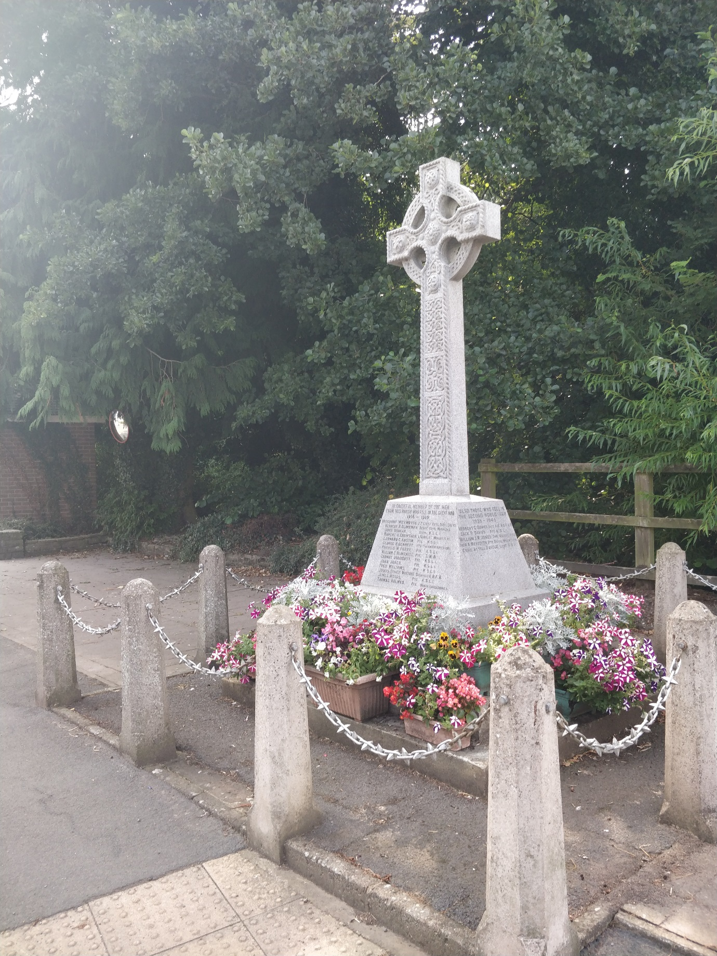
Minsterley is a village with a long history, and despite its recent growth and industrial sites it retains some interesting historic buildings among them attractive cottages’ the fine Tudor Minsterley Hall currently undergoing restoration, and the pariah church which is a most unusual building dating from 1692 and containing an important collection of 18th century maidens garlands. Local toll houses date from the establishment and improvement of the turnpike network; on in the village centre of of particular interest despite its rather dilapidated condition. There is a Victorian cast iron urinal in the village square. Above the village Callow Hill is an ancient site.
Many of these buildings and other features were the subject of comments in the returned questionnaires. Most people were happy to see a specific area of the village designated as a conservation area, but there was wide variation in the buildings and other sites regarded as meriting special treatment. The toll house was the most often suggested; others beside those mentioned above included the parish hall Chapel Farm barn the old part of the school the cemetery and the Minsterley brook. There was substantial support for the restoration of the toll house, perhaps following purchase by a conservation body; some respondents suggested it might be moved to another site. There was also concern that continuing quarrying on Callow Hill posed a threat to the Roman and Iron age site.
There were mixed views on whether more should be done to encourage visitors. ‘There are already too many strangers wandering around’ was one comment whilst another said that ‘as an industrial village Minsterley is not very scenic or attractive to visitors’ Others however felt that the village could be better advertised with a local information leaflet; and that a bit of tidying up would go a long way. A café in the village was another suggestion to encourage those passing through to stop for a while.
There was strong support for setting up of a permanent archive of local history and many people were prepared to offer help with artefacts reminiscences and practical assistance. About 2/3 of those responding were likely to make use of such an archive. Additional comments included suggestions for community festivals, a craft fair at the parish hall; a market in the village centre; and art and craft workshops. Arts activities with song and dance were also suggested.
There were mixed views on Parish twinning with a small majority against, some of whom clearly felt that such a project would be a waste of time and money. Some of those in favour added the proviso that it should not become an excuse for ‘junketing’ and should be open to all and not just ‘the favoured few’ One respondent noted that there was already a twinning arrangement between the churches of the Pontesbury deanery and those of the Swabach Deanery in Germany, in which Minsterley people had participated enthusiastically over recent years; it would perhaps be better to build on this than to try to establish something else.
Recommendation
a) Restoration of the toll hose in the village should be pursued; this will probably involve purchase from the present owners and the advice and co-operation of statutory and voluntary bodies involved in conservation of buildings should be sought. Possible future use of this building for community activities should be investigated.
b) Cost-effective ways of making our village more attractive to visitors should be pursued but major expenditure in this area is probably not advisable.
c) An archive of local history should be established bringing together and adding to those items already collected. A reminiscence project could be set up and the recent photography project followed up.
Toll house now a private residence. An archive would be useful but where to put it?
F/ RECREATION & SPORT
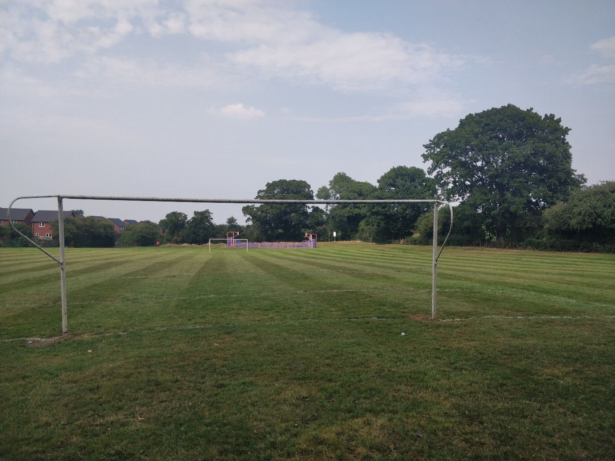
There is a sports field in the village, maintained by the parish council and used by a football team and a rounders team. Facilities at the sports field are somewhat Spartan, the changing rooms having suffered from vandalism over the years were removed and a facility developed in the Parish Hall. Efforts to use planning and development to obtain a permanent structure have been frustrated. There is a bowling green at the Crown & Sceptre. Children play football on the school field. Tennis courts opened many years ago in the village now no longer exist.
Not surprisingly a number of those responding to the questionnaire wanted improvements to the facilities at the sports field including new changing rooms car parking and toilets though there were few people practical help other than regular users. The gate to the field is kept locked and whilst there is pedestrian access via stiles for some this was a difficulty. One respondent suggested that the field would be better looked after by the clubs themselves than by the parish council. Several people observed that the sports field could be better signposted; a number of villagers did not know where it was and said so.
Several people asked for tennis courts in the village and others wanted basketball and nettle facilities, badminton(perhaps with other indoor sports in the parish hall) a cycling course and cricket facilities. There was one request for a croquet lawn. One respondent suggested that it would be better to concentrate resources on the existing site at the Mary Webb School, Pontesbury which was within easy reach. Many people commented that facilities to enable children and young people to develop sporting skills were of vital importance.
Looking more widely at recreation a film club in the village was suggested and facilities for young musicians. Creative dance and drama also featured in one response.
Recommendation;
a) Ways of attracting voluntary help for the improvement of changing and other facilities at the sports field should be pursued.
b) The use of the Parish Hall facilities for indoor sports especially during the winter months should be promoted
c) In seeking to improve facilities for young people sport should be a significant element in our thinking and action.
d) We should support and seek to promote any scheme for improving the sports facilities at Mary Webb school and their accessibility to Minsterley residents.
Lack of facilities at sports field led to use of parish hall Further development useful but all our money seems to go to Shrewsbury for the sports village.
G/ LOCAL SERVICES
Taken together, Minsterley and Pontesbury are quite well provided with local services, compared with many centres of population of comparable size. Having said this there are some significant facilities that are absent in Minsterley itself, including chemist, doctors surgery, bank, and (except the old urinal in the square) public toilets.
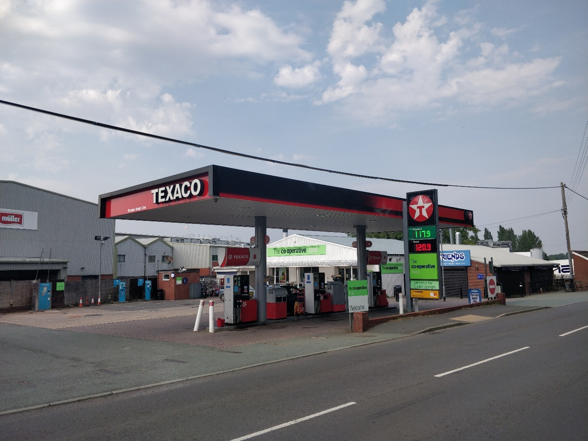
This was the section of the questionnaire that elicited the most response and also the most varied response. Minsterley has reasonably good basic shopping facilities and about 40% of those questioned travelled at least weekly by car to shop in the village. Not surprisingly there is a car parking problem in the area by the shops, which can be quite congested from time to time. There was substantial agreement that the village needed car park facilities for visitors and others; and ¾ of those surveyed said they would use a car park even if it involved a short walk to the shops(however the questionnaire did not specify how short that walk might be) About the same proportion said that there should be public toilets in the village as with car parking facilities the main problem is one of location.
Well over 90% of those responding to the Appraisal used the local Post Office facilities. Some would like to see those facilities extended principally to include taxing of vehicles. Some people would also like to see a greengrocers a chemist and a café or take away in the village.
Slightly more than half of those responding thought that streets and pavements in the village were not clean enough. There were specific comments about dog mess and also autumn leaves and the dumping of garden rubbish. There were places where rubbish seemed to accumulate notably adjacent to Longleat Close. The pavements outside the church were noted as being in need of more frequent attention than they presently receive; leaves and the mess left by birds gathering in the churchyard trees were the problem here. Some people felt that road sweepers should visit rural communities like Minsterley more often than they did and others suggested sponsored litter picks as one way of keeping the place tidy. Involving children in this would help get an anti-litter message across to a new generation. There were appreciative comments about the work in the square of the street cleaner employed by the Parish Council. Some respondents complained about uncut hedges but there was also the comment that hedge clippings were not always cleared away and could get stuck in the paws of dogs.
Recycling facilities in the village were removed following Shropshire Council policy change.
Questions were asked about Medical services. Over ¾ of those making response used the surgery in Pontesbury with appreciable numbers using the Westbury and Worthen general practises. Only about 3% travelled to Shrewsbury or elsewhere to visit a doctor. There was the comment that ‘doctors need to be more accessible’ and a substantial degree of support was expressed for a surgery in the village if this were possible. This would be unlikely to happen but perhaps some clinic facilities could be made available such as chiropody or a well man/well woman clinic which as one respondent observed would particularly benefit the elderly. However others saw no need for any facilities to be provided locally noting that even in urban areas a journey of two miles to visit a doctor was not unusual.
About ¼ of those replying had needed or wanted to contact the local police over the past 2 years, No particular problems were reported but several people commented that they would like to see a stronger police presence int eh village and provision or revival of neighbourhood watch. Most people were aware of the Good neighbours and Voluntary Car schemes operating in Minsterley.
There was quite a lot of interest in developing facilities to serve the wider community. The question as asked referred particularly to use of the Primary School and in particular the development of computer and office(teleworking) facilities. About 1/3 of those responding thought they might make use of resource centre facilities of this sort though several thought that this would be better provided at the Parish Hall. There was in a computer club; other suggestions included a forum-type meeting or evening and weekend classes and provision of picnic tables on the land around the Parish Hall.
Recommendations
a) Further consideration should be given to the possibility of establishing a public car park and public toilets perhaps at he Parish Hall or elsewhere if a site can be identified and outside funding obtained if available.
b) There should be consultation with local medical practitioners to determine whether any facilities could be provided in the village.
c) Consideration should be given as to whether a project for teleworking facilities in the village would be viable and attract funding.
d) The Parish Council should look again at neighbourhood watch provision organisation and funding.*
• = The Parish Council are now in consultation with the neighbourhood watch organiser Mark Fischer and the Police re the scheme.
Is computer access required? Many have home pc’s. Could school suite be used
H/ PARISH HALL
Minsterley has a large parish hall which has good facilities, and is administered by a committee on which all regular users are represented. Most of those responding to the survey felt that the facilities offered were adequate or better with about ¼ describing them as very good. Of those responding to the questionnaire however, less than 20% used the hall monthly or more often and over 50% used it ‘rarely or never’ which must be a cause for some concern. Local use of the hall (over the past year) was mainly for social events meetings of clubs and organisations, and the annual Minsterley Eisteddfod. About 10% of those who had used the hall had been there to give blood. 12% had booked the hall themselves at some time in the past 2 or 3 years.
Comments included ‘an excellent and well run hall’ and ‘a dedicated committee’. Others however wanted ‘new blood on the committee’ and some people felt that the hall was too expensive to book and there were too many rules. Many of these rules were imposed from outside, by the licensing authorities as advised by the Police but clearly they were having a definite impact on opinion if not usage: people wanted to be able to pay at the door, to be able to hold teenage disco’s and eighteenth birthday parties, and there was a feeling expressed that there should be lower rates for users living in the village. Other comments included; better publicity on how to book the hall, and a notice board for hall events; improvement of the external appearance of the hall and surfacing and lighting the car park; a loop system for the hard of hearing and carpeting the floor in the Callow room.
There were a number of positive suggestions for additional community use: more daytime use including perhaps adult education or a ‘Minsterley Forum’ use of the main hall for sports activities; and more entertainment and arts events (including perhaps touring theatre companies) to attract people and cater for all tastes. Another suggestion was that there should be a special reduced rate availability for a limited number of charitable fund-raisin ventures each month or quarter.
Generally the feeling expressed seemed to be that the village had an excellent facility in the Parish Hall and that it was well stewarded, but more community use could be made of it.
Recommendations
a) The Parish Hall committee will no doubt want to take note of the various comments and suggestions made, and act on them in whatever way they feel appropriate. One particular recommendation however is that a notice board be provided.
b) Possibilities for improving the external appearance of the the Parish Hall grounds including car parking should be explored(see the recommendations in the previous section) it may be that a project could be devised that would attract outside funding.
c) An open meeting could be held in the village to look at ways of using the hall(along with other facilities) for arts events.
d) The possibility should also be explored of a drop in coffee morning or afternoon or a forum-type event with a speaker as a way of promoting more local usage of the hall on a regular basis.
e) Many of above are still valid if seen as required
I/ EMPLOYMENT
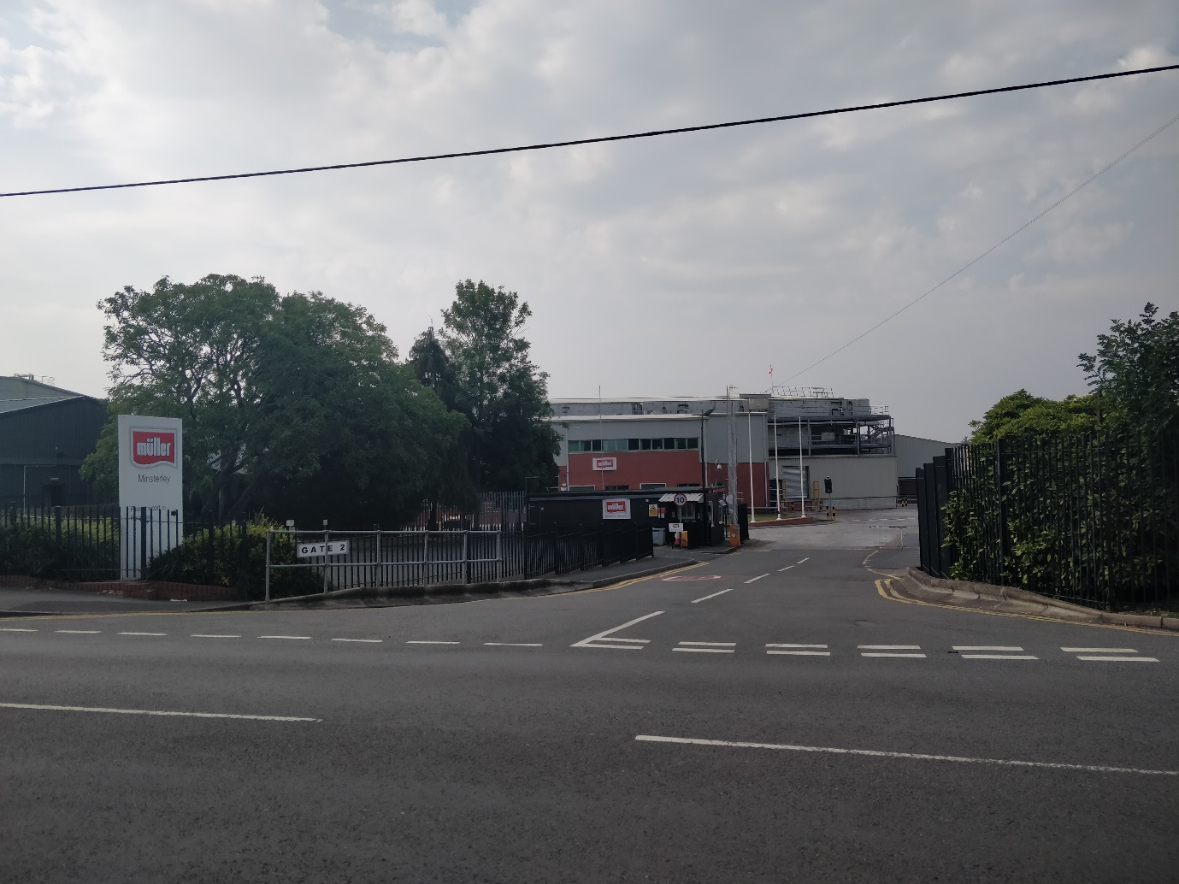
Minsterley is a village with sizeable centres of employment, but the generation of opportunities for small business is still important. Although not much more than 10% of those responding would be interested in starting a business themselves there was substantial support for moves to generate employment opportunities of this type. Most people were not aware of the range of grants available to help new business ventures.
The three suggestions for local business ventures canvassed within the questionnaire (taxi, childcare, rural crafts) were all popular with those responding with a taxi firm receiving most support. There were other suggestions for example additional retail outlets, though others pointed out that no additional business that had to depend entirely on local sales was likely to be viable.
Light engineering building repairs and decorating were all suggested but one respondent insisted that ‘workshops must not be unsightly as this would scare off tourists’ The tourism industry was seen as a viable source of employment opportunity especially on the Bishops Castle side of the village. Suggestions included a café and sites for campers and caravanners. Small industries that serviced the agricultural industry e.g. servicing milking machines were also suggested.
One suggestion was that opportunities should be created for single mothers to work in the village; and there were several comments concerning the kind of practical help that would allow people to get back into employment e.g. a creche to enable mothers to work shifts at the creamery.
Recommendations
a) Local councillors should continue to support schemes to provide workshop facilities at reasonable rent in the village, provided the demand is there and there is not a detrimental impact on the overall appearance of the village.
b) Efforts should be made to improve awareness of the grants and other supports available for those seeking to start small business ventures.
No apparent demand for workshop facilities. They can be found at Malehurst if required. Does anyone have knowledge of available grant or where to access them?
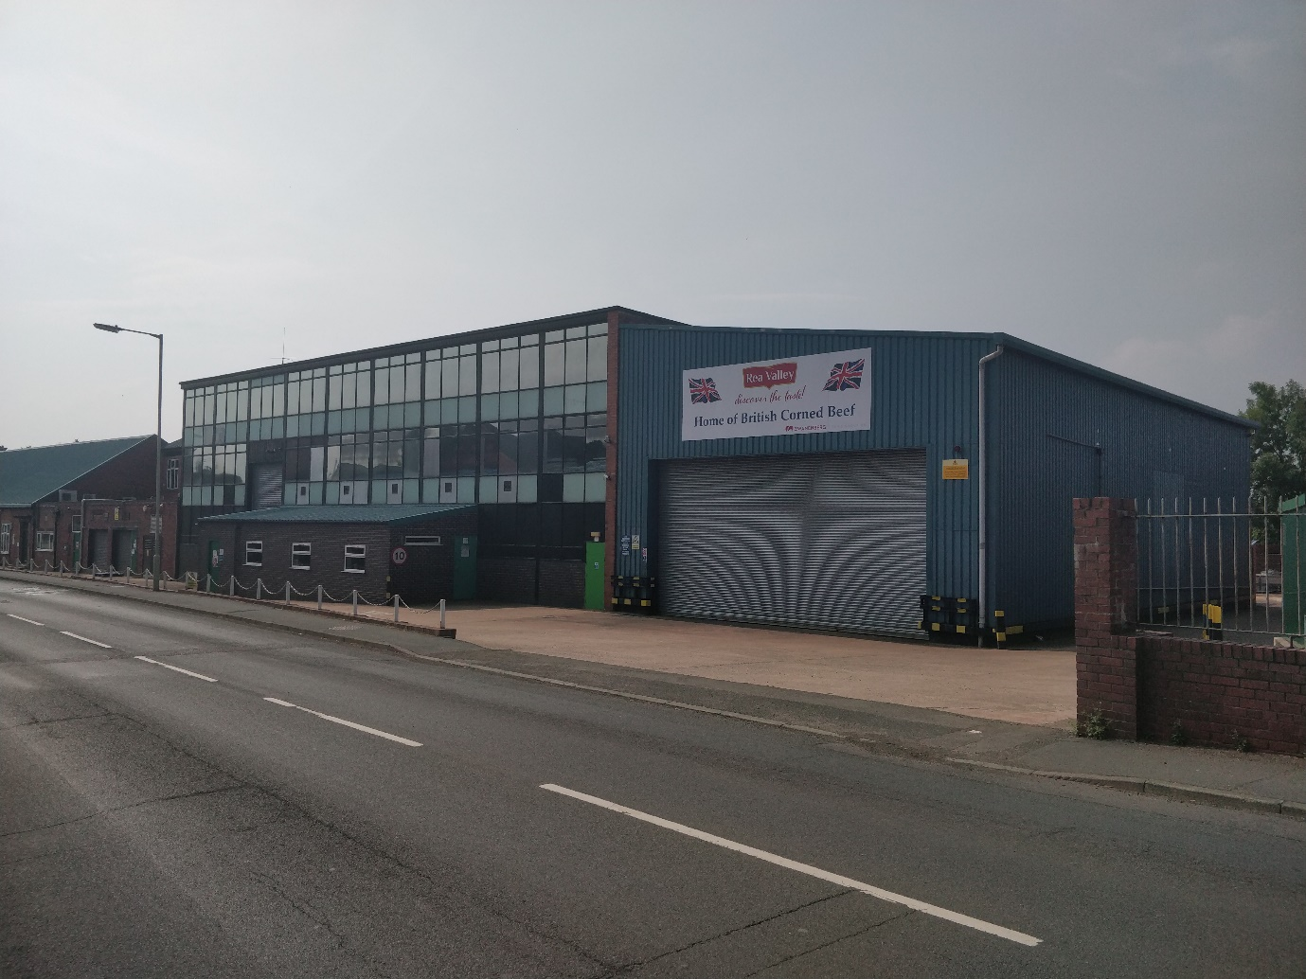
J/ HOUSING
Minsterley has grown substantially over recent years with a number of new housing developments. In the short term at least however no further building is planned. Most people surveyed did not want to see further growth in the size of the village though some would be prepared to accept it if better local services were provided. About a third wanted no further building but a reasonable number would be happy to see infilling within the present village boundaries. Over ¾ of those responding owned there own home; of the remainder the largest proportion were council tenants. Just over 20% would want to move to a new home within the next 2 to 3 years two thirds of whom would expect or hope to remain in Minsterley.
Some people were happy with the suggestion that more starter homes and senior citizen accommodation be provided locally. However some respondents expressed concern about further growth; ‘We don’t want to become a mini town’ and @There are already too many housed for the facilities’ were two comments made. Another resident observed that there were problems when urban families were re-housed in rural areas and this should be avoided. One person commented that there were 2 priorities; to provide better for the old, and to encourage the young to stay; other than that the existing provision was adequate. One suggestion was for cheaper building plots on which one could build one’s own home. The view was also expressed that council property was often left empty for too long.
For the most part the important issue was the character of the village coupled with the adequacy of its facilities. There was a feeling that Minsterley should not grow too quickly and should not lose its rural identity. There was general support for a further more detailed study of local needs.
Recommendations
a) A more detailed survey of local housing needs should be carried out at some point in the near future.
Further small developments have taken place but the demand for housing is still there and many of the ‘infill sites’ have been filled. Affordable housing for locals may become an issue but not as yet. The last large developments are now 10 years old. There is no obvious area for development but increasing demand may force the hand of the council. The local plan is still awaited.
Any housing developed should have green assets, each home should have solar heating, be fully insulated, built from sustainable materials, have access to electric car charging points.
Any development should incorporate green space amenity land,
Any lighting should be LED and be to highways standard and
All development must be within the development boundary of the village..
k/ ACCESS TO THE COUNTRYSIDE
Minsterley is surrounded by some attractive countryside and there are many places where walkers or cyclists can roam quite freely. In some parts of South Shropshire walks have been developed waymarked and marketed as part of a project to attract tourism. Could that be done here?
About 20% of those responding to the questionnaire used local footpaths at least weekly. Support for their development was very strong(over 90% of responses) and many would like to see a footpath map displayed prominently perhaps on the Parish Hall Car Park or at the Post Office. One comment was use of local footpaths was complicated by the fact that road walking between them was dangerous. There was a feeling that better signposting was needed and some paths could be improved, especially the old road from Leigh rd to Plox Green. There were comments also that dogs should be kept on loads and that signs to that effect should be displayed at each footpath; and that people should keep the designated path and not wander about or take short cuts. The replacement of some stiles by gates would improve access for those who were no longer as agile as they once had been.
Questions were asked about open space and natural features in the village. The majority of those responding thought that there was sufficient open space in the village though the comment was made that there were no public areas where dogs could be let off leads. There were a number of comments about the brook ranging from ‘leave it alone to pipe it and fill it in’ Most people who expressed an opinion felt that it should be tidied up and native plants and shrubs planted along the bank. Voluntary helpers could clear rubbish; generally speaking it was felt that the local community should be responsible for the local environment.
Other suggestions made in this section included: the setting up of a Christmas tree each year in the square; improvement of brookside walks, and of old and derelict buildings; more spring bulbs(along with some applause for the present displays) and the formation of a parish walking group. Some residents asked ‘What has happened to the parish paths partnership? Others wondered where the money would come from to improve paths and to advertise them.
Recommendations
a) A footpath map and leaflets should be developed perhaps by seeking outside funding.
b) Work to enhance the brook as a natural feature of the village should be set in had a survey to determine what should be done might be a good idea but funding would be needed for this, and agencies offering conservation grants should therefore be approached. Whatever was proposed would need to be sustainable in terms of its ongoing maintenance.
Map provided though leaflets have now dispersed. Footpath group needs some work and the PC is trying to revive it.
L/ SENIOR CITIZENS
Minsterley has an appreciable number of people of pensionable age within its population many of whom lead very active lives. Some have moved into the area after retirement while others have spent their whole life in the area and in that time have seen many changes. The largest proportion of those responding to the survey reckoned that local services and facilities for senior citizens were adequate with appreciable minorities either side listing them as good or poor. A few people used day centre facilities in Pontesbury (shortly to move elsewhere at the time of the survey- in fact to Hanwood) There was a strong feeling that day centre facilities in Minsterley would be good thing.
Travel problems were one area of great concern especially getting on and off buses. This age group found particular difficulty in arranging travel to and from doctors surgeries. Other comments were; the need for somewhere other than the Longleat Close community room for elderly people to meet – perhaps in a drop in centre in the parish hall; more help for those who were housebound; wheelchair pushers to help disabled people get out and about. And help in crossing the road to and from the Post Office and bus stop. One resident of Longleat Close commented ‘ I think that the facilities at Longleat are good for OAP’s but bus services and medical service are poor’.
Recommendations
a) Certain recommendations from previous sections are relevant here, including liaison on bus provision and encouraging greater use of the Parish Hall for local facilities b) Wheelchair pushing may well be one service already provided by the Good Neighbours Scheme; it may be an area where young people in particular could offer help.
c) Local Parish Councillors could meet with Longleat Close residents (and warden) and perhaps other senior citizens on a regular basis to be made aware of particular problems or issues of concern.
Transport nearer to longleat?
M/ LOCAL COUNCILS
A few questions were added to the survey to test peoples knowledge of the local councils and their responsibilities and to find out how communication could be improved. More or less equal numbers of those completing the questionnaire knew or did not know who their local councillors were, and understood or did not understand the different roles and responsibilities of each tier of local government. There was a fair degree of support for a local surgery at which county and borough councillors would be available to their electors and for the publication of a village newsletter. One respondent commented that the parish notice board was too crowded and it was hard to find things there another asked for a booklet listing local amenities. There was no clear preference for single over multi member wards with nearly half expressing no preference. Many people thought the Council tax bill for Minsterley was comparatively high ‘too high for the level of services provided’. The view was also expressed that the present (borough) councillors were more interested in Pontesbury than in Minsterley.
Recommendations
A) A newsletter should be published on a regular basis and delivered free within the parish.
B) Regular surgeries should be arranged and widely publicised with county and borough councillors both attending.
C) The effectiveness of the present notice board facility should be reviewed and improvements made if possible.
Surgery ideas still valid
David Leeson Clerk to Minsterley Parish Council August 2020
END of Minsterley Parish Plan 2020 Update see Appendix A below ↓
================================================================
APPENDIX A Minsterley Parish Plan Update 2022 Tues 13 Sept 2022

LINKING THE FOOTWAYS ON STATION ROAD MINSTERLEY

1) On Wed 13 Apr 2022 MPC held a Site Meeting on Station Road Minsterley with MPC Chair and Clerk plus SC Cllr Nick Hignett and SC Officers Mathew Mead and Ffion Horton

The group inspected the left hand side of the A488 going towards Pontesbury all the way from The Square and past the new homes at Perret Close and on up to the proposed site for yet more new housing at Site MIN018 at the very top of the village in Little Minsterley.

The group informally concluded that this would be a very useful project to improve the local infrastructure for pedestrians as necessitated by all the recent new housing in the village.
The SC Officers undertook to investigate the feasibility of taking this project forward.

2) In the Minsterley Pontesbury and Surrounding Area Place Plan 2019/20 the middle section of Page 8 shows: "improvement of pavement towards village centre Minsterley" to be a Shropshire Council PRIORITY A project.

3) Local businesses have told MPC that pedestrians are struggling to cross entrances on this route especially families with young children in pushchairs to the point where the problem is now a real and present danger to pedestrians under Health and Safety considerations.

4) So Linking the Footways on Station Road from The Square past the Perret Close new housing and on up the A488 to the proposed housing development Site MIN018 West of the A488 is now MPC's TOP PRIORITY 5 for improvement to its community infrastructure.

Signed: ~ Ian A. Hutchinson Minsterley Parish Clerk Tues 13 Sep 2022

Signed ~ Ian A. Hutchinson Minsterley Parish Clerk ⬇
Parish Office Montford Bridge Shrewsbury SY4 1ER
Tel: 01743 850504 Email: clerk@minsterley.org.uk
Mob: 07572 781907 Website: www.minsterley.org.uk

RATIFIED Resolution 2505-6.2 dated Tues 13 May 2025
To be REVIEWED each May at the Annual Council Meeting

END OF APPENDIX A Minsterley Parish Plan

==================================================================

